main.js

|  |
| --- |
| console.log(process.env.NODE_ENV)  console.log(process.env.VUE_APP_MODE)  console.log(process.env.VUE_APP_BASE_URL) |

package.json

|  |
| --- |
| "scripts": {      "serve": "vue-cli-service serve",      "build": "vue-cli-service build",      "build:test": "vue-cli-service build --mode test",      "build:uat": "vue-cli-service build --mode uat",      "lint": "vue-cli-service lint"    }, |

1.1

.env.test

|  |
| --- |
| VUE_APP_MODE=test  VUE_APP_BASE_URL=http://22.22.22.22:8080 |

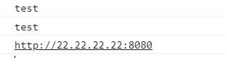

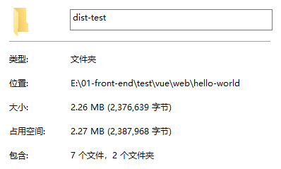

1.2

.env.uat

|  |
| --- |
| VUE_APP_MODE=uat  VUE_APP_BASE_URL=http://33.33.33.33:8080 |

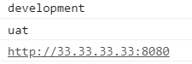

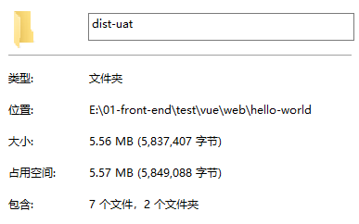

1.3

.env.production

|  |
| --- |
| VUE_APP_MODE=production  VUE_APP_BASE_URL=http://44.44.44.44:8080 |

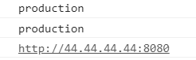

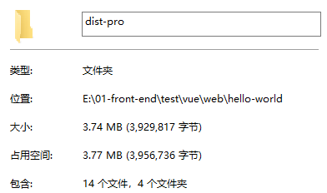

2.1

.env.test

|  |
| --- |
| NODE_ENV=production  VUE_APP_MODE=test  VUE_APP_BASE_URL=http://22.22.22.22:8080 |

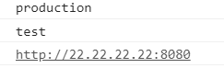

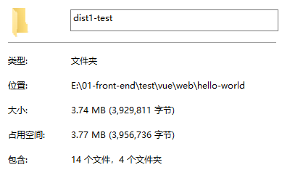

2.2

.env.uat

|  |
| --- |
| NODE_ENV=production  VUE_APP_MODE=uat  VUE_APP_BASE_URL=http://33.33.33.33:8080 |

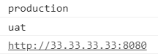

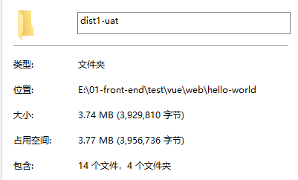

2.3

.env.production

|  |
| --- |
| NODE_ENV=production  VUE_APP_MODE=production  VUE_APP_BASE_URL=http://44.44.44.44:8080 |

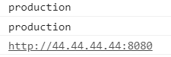

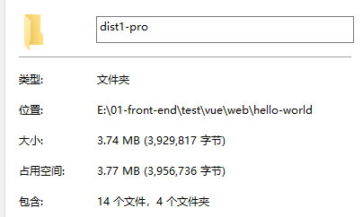

3.1

.env.uat

|  |
| --- |
| NODE_ENV=uat  VUE_APP_MODE=uat  VUE_APP_BASE_URL=http://33.33.33.33:8080 |

